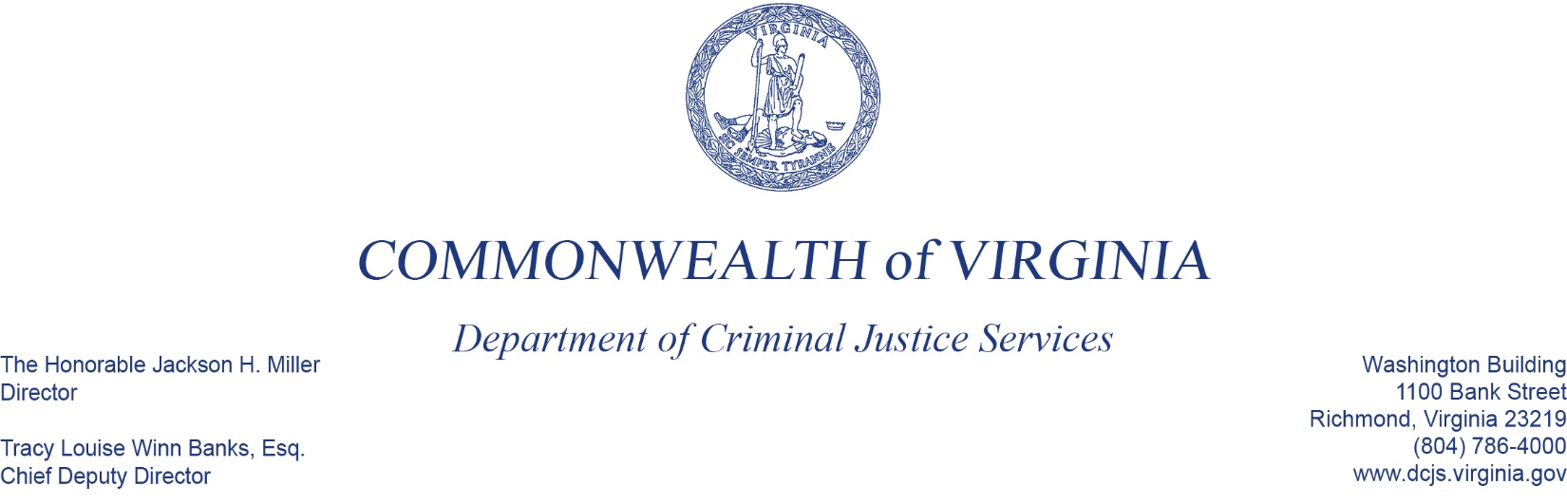
To: Criminal Justice Services Board Grants Committee
From: Tracy Matthews, Law Enforcement Training and Grants Supervisor, Acting Manager
Date: June 2, 2022
Re: FY23 Peer Supported Critical Incident Stress Management Grant Program

You have before you the proposed budget for the Peer-Support Critical Incident Stress Management Grant Program for FY23, totaling $300,000, funding 2 grantees. This a continuation grant, in the second year of a four (4) year cycle.
The grant period for these awards would be from July 1, 2022 – June 30, 2023.
The grants support nonprofit organizations to provide post-critical incident seminars and peer-supported critical incident stress management programs to law enforcement agencies and their staffs.

